ACS Receptor Selection: FABP vs Serum Albumin
Notebook: Paper_4FA_Receptors.ipynb
Dataset: Paper_New_4FA_withoutPSA.xlsx, Paper_Old_4FA_EOnly.csv

3D PCA
Serum Albumin(HAS, BSA, GSA)
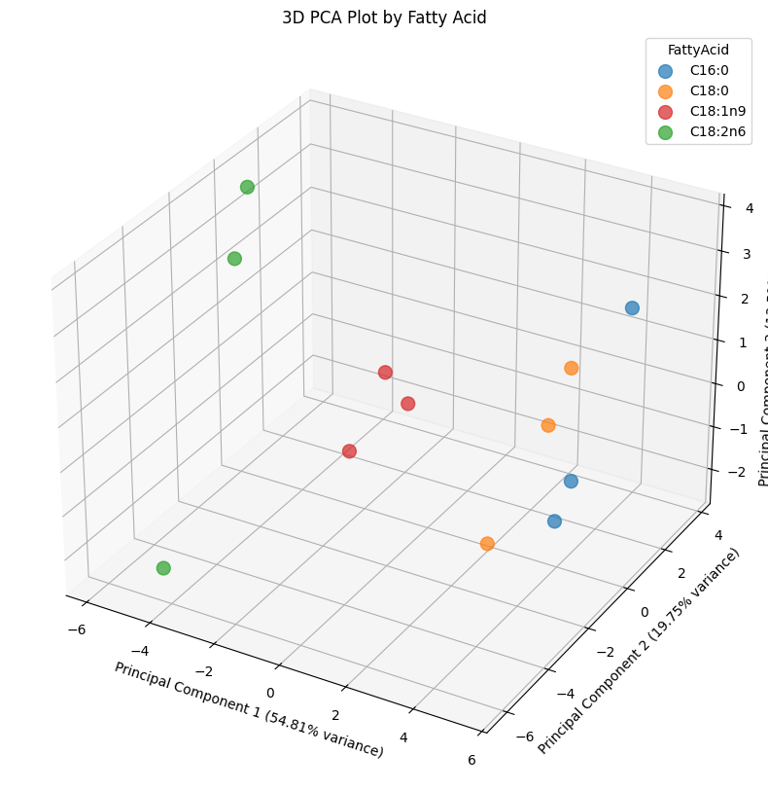
FABP(FABP1, 2,3)
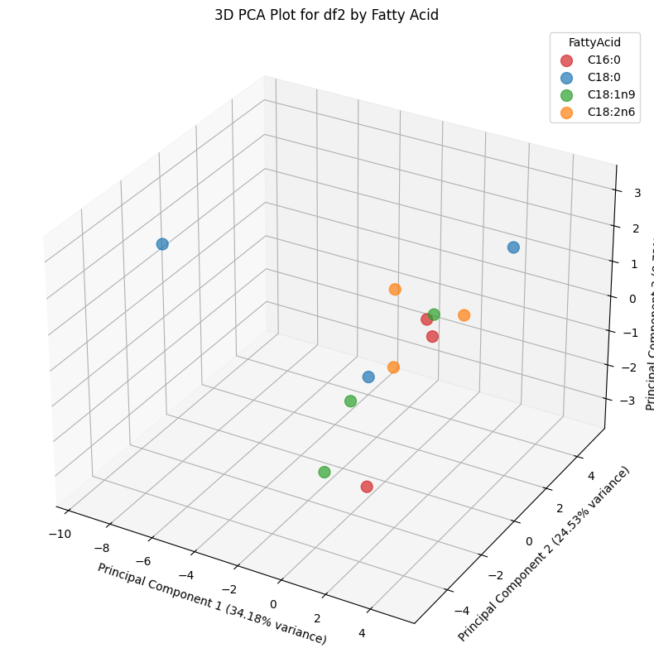

LDA LOOCV

Serum Albumin(HAS< BSA< GSA)

 | Feature Groups | Mean Accuracy | Std Dev Accuracy
1 | GSA_ | 1.000000 | 0.000000
5 | GSA_+HSA_ | 1.000000 | 0.000000
3 | BSA_+GSA_ | 1.000000 | 0.000000
6 | BSA_+GSA_+HSA_ | 1.000000 | 0.000000
0 | BSA_ | 0.833333 | 0.372678
4 | BSA_+HSA_ | 0.750000 | 0.433013
2 | HSA_ | 0.333333 | 0.471405

FABP(FABP1, 2,3_ Ethnol)

 | Feature Groups | Mean Accuracy | Std Dev Accuracy
0 | F1E_ | 0.666667 | 0.471405
3 | F1E_+F2E_ | 0.500000 | 0.500000
1 | F2E_ | 0.333333 | 0.471405
2 | F3E_ | 0.250000 | 0.433013
4 | F1E_+F3E_ | 0.083333 | 0.276385
5 | F2E_+F3E_ | 0.000000 | 0.000000
6 | F1E_+F2E_+F3E_ | 0.000000 | 0.000000

FABP vs BSA
Notebook: ACS_Recetors_OldData.ipynb
Dataset: ACS_OldData_Receptors.xlsx
ACS_OldData_Receptors_Full.xlsx

3D LDA

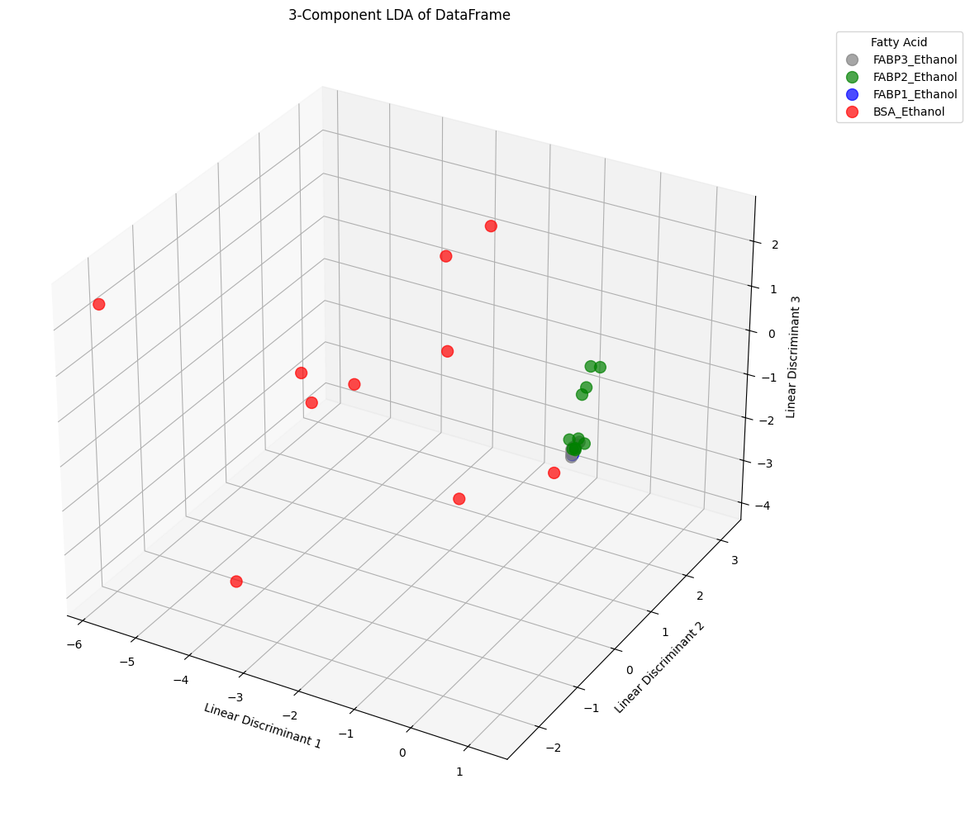

Human Serum Albumin (HSA), Fatty Acid Binding Proteins (FABPs), Peroxisome Proliferator-Activated Receptors (PPARs), and Fatty Acid Transport Proteins (FATPs) form a sequential biological cascade for lipid transport, cellular uptake, and gene regulation. Each has highly distinct structural binding mechanisms and capacities. [1, 2, 3, 4, 5]
Here are the specific characteristics and capacities of these binding proteins:
1. Human Serum Albumin (HSA)
HSA is the primary extracellular carrier for long-chain fatty acids (LCFAs) in the bloodstream. [1, 2, 3]
- Binding Capacity: HSA features multiple binding sites (typically up to 7 sites, with 2 primary high-affinity sites) for various lipophilic compounds, including LCFAs, drugs, and hormones.
- Affinity: Exhibits dissociation constant (\(K_{d}\)) values in the nanomolar to low micromolar range depending on the fatty acid structure. [1, 2, 3, 4, 5]
2. Fatty Acid Binding Proteins (FABPs)
FABPs act as intracellular lipid chaperones and gene-activation facilitators. [1, 2, 3]
- Binding Capacity: Each FABP molecule typically binds 1 fatty acid within its internal water-filled β-barrel cavity.
- Affinity & Specificity: Shows strong \(K_{d}\) values (nanomolar range) for saturated and unsaturated LCFAs (≥ 14C), which correlate directly with the ligand's hydrophobicity. [1, 2, 3, 4]
3. Peroxisome Proliferator-Activated Receptors (PPARs)
PPARs are nuclear transcription factors that regulate lipid metabolism, inflammation, and cellular differentiation upon lipid binding. [1, 2, 3, 4, 5]
- Binding Capacity: They bind 1 ligand at a time within their ligand-binding domain (LBD).
- Functional Coupling: Specific FABPs (like A-FABP and L-FABP) physically dock into PPARs to directly channel and shuttle LCFAs/synthetic ligands (e.g., fibrates) directly to the nucleus for transcription activation. [1, 2, 3, 4]
4. Fatty Acid Transport Proteins (FATPs / SLC27)
FATPs are transmembrane proteins located on the cell surface that facilitate the actual uptake of extracellular LCFAs. [1, 2]
- Binding Capacity & Function: FATPs operate at the cell membrane where they reversibly bind fatty acids and also possess acyl-CoA synthetase activity. [1]
- Mechanism: Upon binding a fatty acid, FATPs immediately convert it to a bulky fatty acyl-CoA, ensuring the lipid remains trapped inside the cell for downstream processing (such as β-oxidation or lipid storage). [1, 2]

